
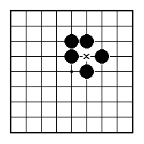
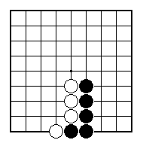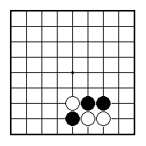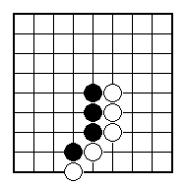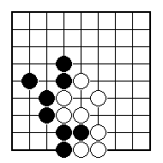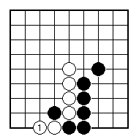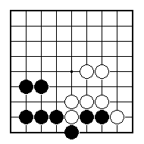
Black to play and win at least one white stone.

White to play and win at least one black stone.

Black to play and win at least one white stone (two possible answers).

White to play and win at least one black stone.

White played at 1. How can Black stop this stone from escaping?

White to play and win at least one black stone (two possible answers).

NAME:
BRITISH GO ASSOCIATION CERTIFICATE LEVEL 2 - SHEET 5

EDGE-OF-THE-BOARD TACTICS

